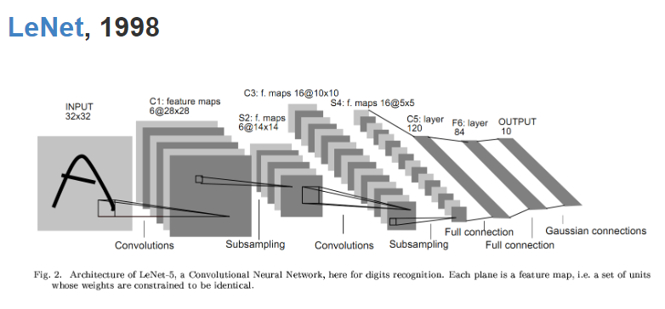

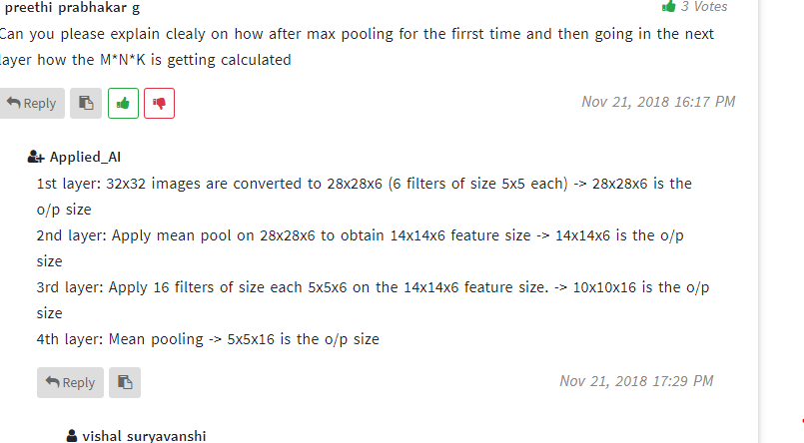

<https://world4jason.gitbooks.io/research-log/content/deepLearning/CNN/Model%20&%20ImgNet/lenet.html>

refer this for complete paper